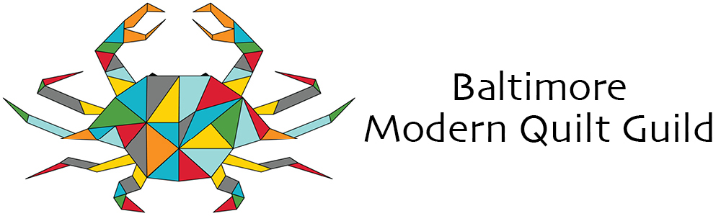
BMQG Newsletter – October 2025 Volume 6, Issue 10

The purpose of the guild is to share knowledge of modern quilting techniques, patterns, modern fabrics and quilt-making by providing meetings, social gatherings, educational workshops and field-trips to support quilting activities, encourage modern quilt-making and promote the appreciation of this craft. The Baltimore Modern Quilt Guild supports and encourages the growth and development of modern quilting through art, education and community.
October/November Events

October

Saturday, October 10th from 10:00 am to 4:00 pm
David Owen Hastings workshop:
Seams Out Quilted Pillow
The workshop will be on Saturday, October 10th (see details below). On Sunday, following the workshop, David will join us virtually for our monthly Guild Meeting. His lecture will be on “Modern Minimal Quilt Design” (see additional details below).

A little about David…

INSTRUCTOR NAME: David Owen Hastings
IG HANDLE: @davidowenhastings
WEBSITE: www.davidowenhastings.com

David Owen Hastings is a modern quilter, speaker and teacher. He creates richly layered contemporary artwork and modern minimal quilt designs. For over 25 years, David has exhibited his modern quilts and stitched paper artwork in galleries and juried shows.

David’s graphic design background and creative approach to modern quilting has led to a busy schedule of workshops and lectures on quilting, fine art and textile techniques. Sharing knowledge, encouraging creativity, and teaching new skills are personal passions. He also loves to travel, especially in Asia, and enjoys sharing his experiences and inspiration through travel photos and stories.

Registration for "Seams-Out Quilted Pillow " with David Owen Hastings is now open!

Here's the link to register. The website may be a little bit slow - if so, please be patient. Add the item to your cart and then check your cart before you hit purchase to be sure that you've only added the workshop once. It can take a few seconds to update.
avel photos and stories.

WORKSHOP DETAILS: SEAMS-OUT QUILTED PILLOW

WORKSHOP DATE: Saturday, October 11th
WORKSHOP TIME: 10:00 AM to 4:00 PM (6 hours)
WORKSHOP LOCATION: Virtual (a link will be shared with registered participants prior to the date)

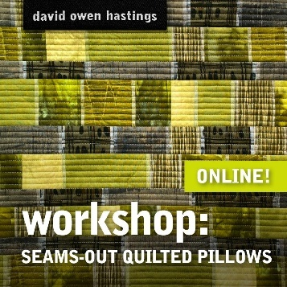
WORKSHOP DESCRIPTION: We usually hide our quarter-inch seam allowances on the back of our quilts, but that’s a missed opportunity for design and texture. In the Seams-Out Quilted Pillow workshop, we’ll make those seams an integral part of the design, adding an artistic touch.

We will make two strip sets, slice and splice them together, and then use the quilt-as-you-go technique and a walking foot to quickly create sumptuous, quilted fabric. Next, we’ll turn that fabric into the front and back of a fabulous, quilted pillow. You’ll also learn to put in an invisible zipper!

Participants will receive guidance for choosing fabric colors, textures and printed designs that allow the seams-out texture to really shine. Once you have the technique down, you can apply the seams-out idea to all kinds of quilted projects.

FEE: Registration is $60.00 for the first 15 people. After that, the price will increase to $75 per additional person up to 24 people. This has to do with how David sets up his workshops.
MATERIALS: A materials list will be provided upon registration

Sunday, October 11th at 1:30 pm
Our regular Meeting and Lecture from David Owen Hastings
Arbutus branch of the Baltimore County Public Library
The lecture will be through Zoom
To attend the meeting by Zoom, use the following link. https://us02web.zoom.us/j/87060038333?pwd=WwU8bdGcEMDc3My0yfl6M8JBpOKsLV.1

LECTURE DETAILS: MODERN MINIMAL QUILT DESIGN

LECTURE DATE and Time: Sunday, October 12th from 1:30 PM to 3:00 PM (1 hour + Q&A)
WORKSHOP LOCATION: Virtual (you’re also encouraged to join Guild Members in person at Arbutus Library)
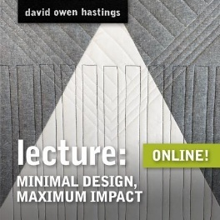
LECTURE DESCRIPTION: This talk gives an overview of my process for coming up with simple graphic quilt designs, starting with stitched paper models (called maquettes). I show examples of how to translate an architectural photo into a quilt design and have many samples of mini quilts I created using this process. The techniques I present are also great for making unique modern quilt block designs. I also talk about walking foot quilting and how to break free from stitch in the ditch.

October Retreat
Friday, October 24 to Sunday, October 26th
https://www.baltimoremqg.com/product/october-2025-retreat/
Registration is now open for the October Retreat 9:00 am Friday, October 24th to 7:00 pm Sunday, October 26th (please note that the start time has changed from noon to 9:00) at the Maritime Conference Center. The cost will be $290.00 which includes continental breakfast, lunch and afternoon snacks on all three days. We will also be providing three classes with a $10 material fee each. One class will be by Diane Winter where she’ll be doing the following pencil box where you’ll learn cartonnage the art of fabric covered boxes.
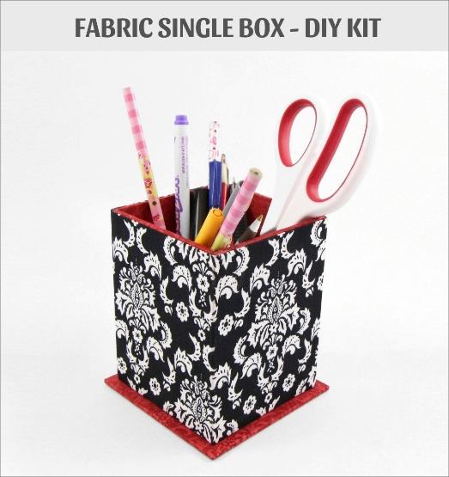
The second class will be by Judy Dunlop on Flying Geese. For this class a pattern and one ruler will be included and there will be two other rulers available for $10 each. There will be a third class by Barbara Shelton that will involve an embroidery/quilting technique.
This year swap pattern “We Women FPP Quilt Pattern”.
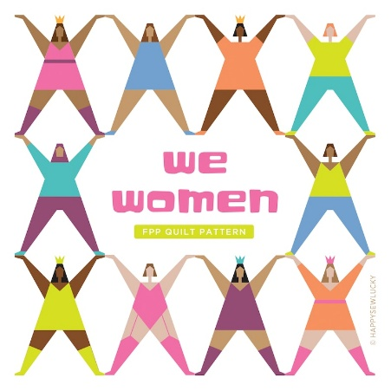
Each quilter will make several “single women patterns” to swamp with other quilters. The pattern will be emailed to you once you have registered for the retreat. Here is a tutorial for the pattern - https://www.youtube.com/watch?v=Ni6hENmrzKk and more pattern ideas can be found at the HappySewLuckShop.

Fourth Quarter Lottery Block
A bear claw and only the claw
The 4th quarter lottery block of 2024 was a Giant block; however for the 4th quarter lottery block of 2025, we are going in the opposite direction as follows: let's make 5" bear claw, just the claw of a traditional bear claw block. I've included the instructions for the claw, along with a picture, at the bottom of this email. Because of the small nature of these cuties, you will receive extra tickets to win for each block entered as follows:
2 blocks: 4 tickets
4 blocks: 6 tickets
6 blocks: 8 tickets
8 blocks: 10 tickets
(10 tickets is the maximum number of tickets, but more blocks are always welcomed!)

Lets get started: (ruler in pic shows measurement at 5")
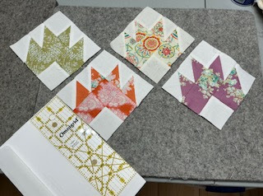

Fabric:
Claws can be a print, small prints work best, or a solid is fine as well, your choice. Background, White or White on White
Cutting:
1)To make 4 HST's_ cut 2 print OR solid and 2 white background to 2 1/2" squares; Place right sides together, (one color fabric with one background) and draw a diagonal line on the wrong side of the white, sew a 1/4" on either side of the drawn line, cut along the diagonal line. I found Pressing seams Open worked best when sewing the block. Square HST's to 2"
2) Cut 2 - 2” background squares, cut 3 - 2" color squares
3) Layout and sew HST and Squares together, per the pic below. Block will finish at 5", (4.5" once sewn into a design)
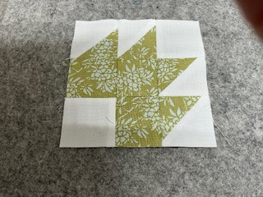
I really enjoyed making these little guys, hope you do as well. Blocks will be due at the December Holiday meeting and depending on the number of blocks, there could be more than one winner. (Will decide at the meeting)

Thank you for participating,
Valarie
BMQG Program Director

Charity Quilt Donations
Donated quilts are being provided for children (infants to 18) at the House of Ruth. The children will keep the quilts once they move away from the House of Ruth. If you have any quilts to donate, please bring them to the meeting on Sunday.
Batting is available to go with the kits and will be at all the meetings.
Amy Krebs, Charity

QuiltCon 2026
Mark your calendars! QuiltCon is returning to Raleigh, NC - February 19-22.

QuiltCon Registration is now open You can find the guide online here: https://www.themodernquiltguild.com/quiltcon/show-schedule

We will be sending information on coordinating carpooling or shared housing in a future communication as well.

Looking Ahead

October
- Saturday, October 11th Seams Out Quilted Pillows zoom w/ David Owens Hastings
- Sunday, October 12th October meeting lecture with David Owens Hastings, Minimal Design, Maximum Impact. Arbutus Library or by Zoom https://us02web.zoom.us/j/87060038333?pwd=WwU8bdGcEMDc3My0yfl6M8JBpOKsLV.1
- October 24th – 26th Fall retreat; Location: Maritime Conference Center.

November
- Design block challenge.
- Saturday, November 8th Quilt as you go – 7 techniques w/ Marie-Claire Charette
- Sunday, November 9th November meeting lecture Quilting as you go (QAYG) is the way to go! w/Marie-Claire Charette

December
- Holiday party.
- Fourth round of lottery blocks due.

Around Town
- Faithful Circle Quilters is holding a silent auction
Quilting and non-quilting items, baked goods and refreshments will be available

Saturday, October 11 Doors open at 10:00 am, bidding from 10:30 to 11:15

First Presbyterian Church of Howard County
9325 Presbyterian Circle, Columbia, MD

Cash, checks and credit cards accepted

Proceeds benefit First Presbyterian's Thanksgiving Food Drive

All are welcome!

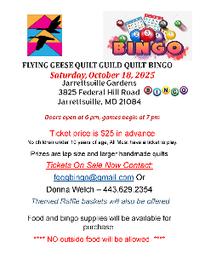

Board Members for 2025

Veronica Jessamy

President

veronica.jessamy@baltimoremqg.com

Karen Jennings

Vice President

Karen.jennings@baltimoremqg.com

Arianna Vogt

Treasurer

arianna.vogt@baltimoremqg.com

Wanda Onafuwa & Leanne Wolff

Director of Education

wanda.onafuwa@baltimoremqg.com

leanne.wolf@baltimoremqg.com

Diane Winter

Director of Membership

diane.winter@baltimoremqg.com

Emily Smith & Linda Barone

Director of Communications

emily.smith@baltimoremqg.com

linda.barone@baltimoremqg.com

Amelia Krebs

Director of Charity Relations

Amelia.krebs@baltimoremqg.com

Valarie McNeese

Director of Programming

valarie.mcneese@baltimoremqg.com

Typical Meetings
We meet on the 2nd Sunday of the month unless otherwise noted.
We typically meet in Baltimore Public Library Meeting Rooms except during the summer. The Library’s policy is that we can only book rooms three months in advance. As such, please continue to check our website for meeting locations in the future. We are not dedicated to a single branch but rather select locations based on availability.
To attend the meeting by Zoom, use the following link. https://us02web.zoom.us/j/87060038333?pwd=WwU8bdGcEMDc3My0yfl6M8JBpOKsLV.1
If you have a friend who you think might enjoy our guild feel free to invite them to one complimentary meeting so they can see what we’re all about.
For more information about our guild and a members only page, go to our website/blog https://baltimoremqg.blogspot.com/

Want to see what we're up to? Connect with us on social media!
Instagram: @baltimoremqg #baltimoremqg
Facebook: BaltimoreModernQuiltGuild
Email us at baltimoremqg@gmail.com

